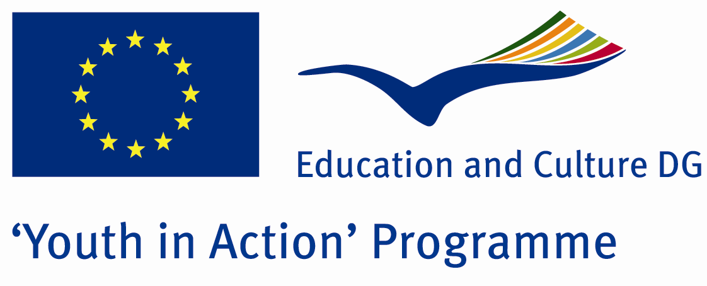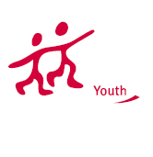

Action 1.1
Project Summary; Nowadays in all over the world, unemployment has been rising day by day and it has threatened our future. When the youngsters who are well educated, after university, hasnt found job, they let down.This disappoinment has broken down the youngsters physicological situation.So, youngsters has been agresif and nervous people.
Here in this Project, we try to learn how we can solve this problem.We try to understand their psyhological situation and we evaluate this situation in terms of our future.
If you want to join this Project, please contact with us.

Project Title; UNIVERSTY FINISHED WHAT LL HAPPEN NOW?

Date and Venue ; 15-22 February 2013
Place: BALIKESİR, Turkey.

Target Group ; Municipalities, City Councils and Non-Governmental organizations,
youth groups,culture and art groups,e.t.c

Participants ; 5 people from each country (over 18 -25 ). Totally 7 countries.

Conditions ; Accommodation, board and programme costs will be financed through European Commission Youth in Action Programme . Travel costs will be reimbursed in 70% (APEX Tarrifs). Organizations from all 27 EU member countries plus Liechtenstein , Norway and Iceland are eligible to take part.

Working language: English

Organisator group:Group Pisida

How to apply: If you are interested, please send your Part III forms to
by e-mail please (in word file). Scan Part3 format is enough for application.(Fulfilled Part III which you can find in the attachment, of course signed and stamped) ..

Contact e-mail: groupsymrnes@gmail.com
Group e-mail: grouppisidia@gmail.com

Deadline to apply:20.09.2012

